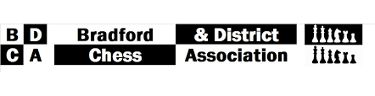

**EGM**

**AGENDA**

**Date:** 3 September 2024

**Venue:** The Latvian Club, Clifton Villas

**Start Time:** 8:00pm

**AGENDA**

1. Apologies

2. Date of AGM 2025

3. Approval of new Bank Signatories:

* David Barlow – Treasurer
* Phil Drury – President
* Andrew Wainwright – Secretary

4. League Structure 20204/2025

* LMS
* Match Cards
* Whatsapp
* Handbooks – including reminder of rule changes following 2024 AGM

5. Boyd

6. Hepolite

7. Clough

8. Individuals

9. Individual Lightning

10. Bradford Congress 2025

11. AOB